Instructions: This letter covers tax return preparation for individuals and different entities. The yellow highlighted sections provide guidance on what you may wish to tailor for particular clients.

[Insert DD Month YYYY]

[Insert Client Name]
[Insert Client Position]
[Insert Company Name]
[Insert Company Address]
[Suburb State Post Code]

Dear [Insert Client Name]

Re: Year-end tax preparation

As year-end is rapidly approaching, I am writing to encourage you to contact our office to arrange a meeting to discuss tax preparation matters.

I have also prepared a list of records you may wish to bring with you when we meet concerning the preparation of [Delete as applicable: your individual income tax return for the year ended 30 June 2021 or the income tax return for your company, trust or partnership for the year ended 30 June 2021 or your group income tax returns for the year ended 30 June 2021] which is attached as Appendix 1 to this correspondence.

YEAR-END CONSIDERATIONS

Please find detailed below commentary on certain categories of tax planning issues that you may wish to consider in the lead up to year-end. [delete relevant sections below as appropriate]

BUSINESS YEAR-END TAX PREPARATION ISSUES [delete if not in business]

Some key business issues which may be relevant prior to the end of the financial year are outlined below. A number of these are new measures introduced by the Federal Government to assist businesses and rebuild the economy due to COVID-19, including:

- The introduction of ‘Temporary full expensing’ (TFE) and 'Backing business investment' (BBI) accelerated depreciation
- Extending the instant asset write-off (IAWO) measures to assets costing $150,000 or less
- Introduction of the ‘loss carry-back’ regime and
- Expansion of certain small business tax concessions.

Tax depreciation incentives

Numerous tax depreciation incentives have been introduced or extended in the prior year. The various measures have different eligibility requirements and application dates. It is also necessary to consider the interactions between the different measures. In effect most businesses should be able to write off the full amount of the cost of eligible depreciable assets in the 2021 income year, whether under the TFE rules, the BBI or the IAWO.

The application of these rules generally depends on:

- The turnover of the taxpayer
- The type of asset
- The cost of the asset and
- The date of acquisition / date the asset is installed ready for use.

The ATO has developed a guide for determining eligibility of the tax depreciation incentives which is available at https://www.ato.gov.au/Business/Depreciation-and-capital-expenses-and-allowances/In-detail/Interaction-of-tax-depreciation-incentives/ and has been reproduced in Appendix 2.

Loss carry back [delete if not a company]

The loss carry back rules provide companies with aggregated turnover of less than $5 billion the option to carry back a tax loss for the 2019-20, 2020-21, 2021-22 income years.

The amount of the loss carry back for the 2019-20, 2020-21 or 2021-22 income year is limited to the lessor of the amount of tax paid in earlier income years, being the 2018-19, 2019-20 or 2020-21 income years (as relevant) and the amount of the franking account balance at the end of the income year the loss carry back is being applied. The losses that can be carried back are multiplied by the prevailing company tax rate in the loss year to determine the amount of the non-refundable offset.

It was announced in the 2021-22 Federal Budget that the loss carry back measure will be extended to the 2023 income year.

Expansion of small business tax concessions

An SBE can access a range of tax concessions. From 1 July 2020 businesses that are not SBEs because their turnover is $10 million or more but less than $50 million are also eligible for:

- An immediate deduction for eligible start-up costs incurred from 1 July 2020 and
- An immediate deduction under the 12-month prepayment rule for prepaid expenses incurred from 1 July 2020.

Cash flow boost

Cash flow boost amounts received by eligible entities during the 2021 year are treated as non-assessable non-exempt income.

JobKeeper Payment

JobKeeper payments received by eligible entities are assessable income of the entity. Deductions for payments to employees are available provided the general requirements for deductibility are satisfied.

Lower company tax rate [Delete if not company]

It is critical to determine whether or not a company is a base rate entity for the purposes of determining the amount of its income tax liability for the year ended 30 June 2021.

A company which is a base rate entity will pay tax at a rate of 26% on its taxable income for the year ended 30 June 2021 whereas a company which is not a base rate entity will pay tax on its taxable income at the 30% tax rate.

A company will be regarded as being a base rate entity if no more than 80% of the company’s assessable income comprises ‘base rate entity passive income’ (BREPI) and its ‘aggregated turnover’ is less than $50 million for the year ended 30 June 2021. For these purposes aggregated turnover is only calculated on the relevant annual turnover of the company and its affiliates and connected entities for the current year being 30 June 2021.

A company’s BREPI includes the following:

- Distributions (e.g. dividends) other than non-portfolio dividends. A non-portfolio dividend is defined under section 317 of the Income Tax Assessment Act 1936 (ITAA 1936) to mean a dividend paid to a company where that company has a voting interest amounting to at least 10% of the voting power in the company paying the dividend
- Franking credits attached to dividends
- Non-share dividends
- Interest income or a payment in the nature of interest
- Royalties and rent
- Deferred and discounted gains on Division 16E qualifying securities
- Net capital gains
- Amounts included in partnership or trust income distributions of net income to the extent that they are attributable to BREPI under one of the preceding items which has been on-distributed to a company which is a partner in a partnership or a company which is a beneficiary of a trust.

Accordingly, an amount that flows through a partnership or trust to a company (either directly or indirectly via other interposed partnerships or trusts) will retain its character in the hands of the company for the purposes of determining whether or not that amount is BREPI of the company. Hence, it is necessary to analyse and dissect partnership and trust distributions (including distributions via a chain of trusts and partnerships) to determine the nature of the income which is received by the company where it is either a partner in a partnership or a beneficiary of a trust.

Where the distribution comprises a mixture of BREPI and trading income it will be necessary to allocate expenses in a fair and reasonable way particularly in relation to indirect costs such as overheads.

Once it is determined that the appropriate company tax rate is either 26% or 30% all of the income derived by the company will be subject to tax at the applicable rate whether such income is BREPI or not.

Moreover, where there is a privately owned group of companies which has not been consolidated it will be necessary to apply the BREPI test to each company in that group to determine the rate of tax payable by that company.

Changed imputation rate [Delete if not company]

In addition to determining the tax rate of a company, there is also the need to consider the application of the dividend imputation rules that apply to the franking of dividends by a company.

Under the dividend imputation system, the amount of franking credits that can be attached to a dividend by a company cannot exceed the maximum franking credit for the distribution.

The maximum franking credit is in turn calculated by reference to the company’s corporate tax rate for imputation purposes.

Importantly a company’s corporate tax rate for imputation purposes is calculated differently to its company tax rate for the current year. Hence, in certain circumstances a company’s tax rate for an income year may be different to the rate at which it can frank dividends in that year.

The corporate tax rate for imputation purposes is defined under section 995-1(1) of the ITAA 1997 to mean the company tax rate of a company worked out on the assumption that:

- Its aggregated turnover for the income year is equal to its aggregated turnover for the previous income year
- Its BREPI for the income year is equal to its BREPI for the previous income year
- Its assessable income for the income year is equal to its assessable income for the previous income year.

Thus, in determining the extent to which a dividend can be franked in the 2021 year by a company, reference will be made to that company’s aggregated turnover, base rate entity passive income and assessable income derived in the 2020 year.

For example, where the company had an aggregated turnover of less than $50 million and no more than 80% of that company’s assessable income is BREPI for the 2020 year it will apply the lower corporate tax rate of 26% in the 2021 year for franking purposes. Where this criteria is not met the corporate tax rate for imputation purposes will be 30%.

However, where the company did not exist in the previous year its corporate tax rate for imputation purposes will be deemed to be at the lower corporate tax rate of 26% for that initial year.

Small business tax offset [Delete if not sole trader or receiving small business income via a trust or partnership]

An individual is entitled to the small business income tax offset for the year ended 30 June 2021 being 13% of the income tax payable on the portion of an individual’s taxable income that is their ‘total net small business income’.

This non-refundable offset is available to sole traders who would meet the requirements of being a small business entity, and to individuals who are not a small business entity, but who are assessed on a share of the net income of a small business entity in which they are a partner in a partnership that is a small business entity or a beneficiary of a trust that is a small business entity.

An entity is a small business entity for these purposes if it carries on business and its aggregated turnover for the 2021 year is less than $5 million. An individual is only able to claim one small business tax offset for an income year irrespective of the number of sources of small business income derived by that individual and the maximum amount of the offset is capped to $1,000 per year.

Small business CGT (SBCGT) concessions

There are significant tax savings potentially available where an eligible active asset used in a business is sold at a capital gain, and the taxpayer can satisfy either the $6 million maximum net asset value test immediately before the CGT event or the $2 million CGT small business entity test (i.e. less than $2 million of aggregated turnover) for the 2021 year.

The SBCGT concessions may also apply to a disposal of shares or units in a small business entity, however it should be noted that additional conditions must be met. Some of these include:

- Where the asset being disposed of is a share or an interest in a trust, the taxpayer must be a CGT concession stakeholder in the object company or trust. Alternatively, if the CGT asset is a share in a company or an interest in a trust which is owned by an interposed entity, the taxpayer must be a CGT concession stakeholder in respect of the object company or trust, and CGT concession stakeholders in that object company or trust must together also have a small business participation percentage of at least 90% in the interposed entity
- The object entity must be a CGT small business entity for the income year or the $6 million maximum net asset value test must be satisfied just before the CGT event. In applying this test it is important to note that a modified connected entity test applies in determining whether these turnover and asset tests are satisfied
- The shares or interests in the object entity must satisfy a modified active asset test that looks through shares in companies and interests in trusts to the activities and assets of the underlying entities.

Given the complexity of the SBCGT concessions, specialist advice should be obtained especially in respect of the disposal of an active asset being a share in a company or an interest in a trust at a capital gain which may be reduced under the concessions.

Trustee resolutions [Delete if no trust entity]

The trustee of a non-fixed trust should document the exercise of any discretion regarding distributions of trust income by 30 June 2021 (or any earlier date required under the trust deed) to ensure that beneficiaries are presently entitled to all trust income and therefore ensure that the trustee will not be potentially subject to tax at a penalty rate of 47% (including Medicare levy) in respect of trust income to which no beneficiary has been made presently entitled.

Such distributions should be made in accordance with the definition of trust income set out in the relevant trust deed. Prior to making such beneficiaries present entitled it may also be prudent for the trustee to determine whether any beneficiaries should be made specifically entitled to capital gains or franked dividends. Care should be taken to ensure that any exercise of the trustee’s discretion to make beneficiaries specifically entitled to such amounts is permitted under the trust deed and satisfies all requirements imposed under the tax law.

Division 7A [Delete if no company]

It is prudent to determine whether any payments, loans or debt forgiveness made by a private company to a shareholder (or an associate of a shareholder) have been made during the year ended 30 June 2021. Where this has occurred during the year it should be determined whether any exemptions potentially apply, and if not, what strategies could be employed to ensure that a deemed dividend does not arise in respect of any such payment, loan or debt forgiveness.

It is particularly important to recognise that an unpaid present entitlement which is owed by a trust to a related private company beneficiary who effectively lends those funds back to the associated trust will be treated as a loan for the purposes of Division 7A of the ITAA 1936.

Previously announced changes to Division 7A that were expected to apply from 1 July 2019 (and later deferred to 1 July 2020) have not been enacted, however it may be prudent to take into account announced changes when considering cash flow or planning issues.

INDIVIDUAL TAX PREPARATION CONSIDERATIONS [Delete if client does not have individual tax return prepared]

The following tax planning measures should be considered in respect of your own individual circumstances.

Salary sacrifice arrangements

If employed, you may wish to review your remuneration arrangements with your employer and forego future gross salary in return for receiving exempt or concessionally taxed fringe benefits and/or making additional superannuation contributions under a valid salary sacrifice arrangement.

However, in entering into a salary sacrifice arrangement it is important to make sure that any additional employer superannuation contributions made in lieu of gross salary do not result in the total of compulsory superannuation contributions and salary sacrificed contributions exceeding the prevailing concessional contributions cap which is $25,000 for the 2021 year.

Alternatively, an employee can claim a deduction for personal superannuation contributions provided certain eligibility conditions are met including the requirement to provide a notice of your intention to claim such a contribution with your complying superannuation fund. You should consult our licensed financial adviser to consider the merits of exploring these options.

Capital gains tax planning

Careful planning should be undertaken in planning the timing of any CGT event in respect of the disposal of appreciating assets which may trigger a capital gain. In this context, it is important to recognise that CGT is triggered when you enter into a contract for the sale of a CGT asset rather than on its settlement which is particularly important where the entry and settlement of the contract straddle year-end.

In these circumstances, it may be preferable for a cash flow perspective to defer the sale of the CGT asset to the subsequent year where other relief may be available such as a capital loss sold on another asset.

However, it is important to note that Taxation Ruling TR 2008/1 provides that an asset sold under a ‘wash sale’ to a related entity to generate a capital or revenue loss to reduce a capital gain will result in the loss being cancelled under the general anti-avoidance provisions of Part IVA of the ITAA 1936 where there has been no significant change in the taxpayer’s economic exposure to the asset.

Care should also be taken to ensure that an eligible asset is retained for the 12-month holding period required to apply the CGT discount, and to recognise that the CGT discount is not available to the extent that any capital gain accrued after 8 May 2012 and you were a foreign resident or temporary resident at any time after that date.

Work-related deductions

You should ensure that any unreimbursed claims for work-related expenses, car expenses and travel expenses are correctly allowable on the basis that such expenses were incurred in gaining or producing salary and wages income or other payments subject to the PAYG withholding regime, including any work-related claims below $300.

Where items are used both for work or business purposes and for private purposes (e.g. use of a mobile phone or home computer) it is also necessary to apportion deductions so that a deduction is only claimed for the business portion of the expense. In addition, all claims for work-related expenses and business travel expenses must be substantiated by way of evidence such as invoices, receipts and credit card statements.

Where car expenses are claimed as deductible using the logbook method it is also necessary to retain all appropriate invoices and receipts as well as maintain a fully compliant logbook. Alternatively, where car expense deductions are claimed using the cents per kilometre method it is necessary that any estimate of business kilometres travelled be based on reasonable estimates which should be appropriately documented.

For employees who were working from home during the period 1 March to 30 June 2021, the Australian Taxation Office (ATO) is allowing a temporary simplified method of calculating deductions for additional running expenses. There are 3 alternatives including:

- 80 cents per hour for all additional running expenses incurred after 1 March 2020 until 30 June 2021
- 52 cents per work hour for heating, cooling, lighting, cleaning and the decline in value of office furniture, plus the work-related portion of phone and internet expenses, computer consumables, stationery and the decline in value of a computer, laptop or similar device or
- Actual work-related portion of all running expenses, which will need to be calculated on a reasonable basis.

Care should be taken in claiming work-related deductions as the ATO continues to scrutinise excessive claims and uses data analytics to detect claims which are unusual or abnormally high relative to other persons in the taxpayer’s occupation or profession.

TAX AND SUPERANNUATION REFORMS IMPACTING PROPERTY OWNERSHIP [Delete if not applicable]

Various taxation and superannuation measures have been legislated in recent years which may impact a taxpayer’s purchase and sale of residential property, and the amount of deductions potentially available to residential rental property owners. The most important of these changes are set out below.

Denial of travel deductions in relation to rental properties

Deductions are not allowable in respect of travel costs incurred in inspecting or maintaining residential rental properties by individuals, discretionary trusts, small unit trusts and self-managed superannuation funds.

Moreover, such expenses cannot be included in the cost base or reduced cost base of the residential rental premises or deducted as black-hole expenditure. Accordingly, it is important to recognise that there is no tax relief for travel costs incurred in either inspecting or maintaining property or collecting rents.

Limiting deductions for second hand depreciating assets

Individuals, discretionary trusts, small unit trusts and self-managed superannuation funds are also denied a deduction for the decline in value of a depreciating asset (e.g. furniture and fittings) to the extent that the asset is used or installed ready for use in residential rental premises, and that asset was previously used by the taxpayer for a non-taxable purpose or was previously used by another entity, e.g. a previous owner.

However, any decline in the value of such second-hand depreciating assets may result in a capital loss (or in certain circumstances a capital gain) on any subsequent disposal of an asset on the basis that the asset has been used for a non-taxable purpose. These rules apply to income years starting on or after 1 July 2017 in relation to depreciating assets acquired from, or owned at, the time the measure was publicly announced on 9 May 2017.

Foreign resident CGT withholding rate

A non-final 12.5% foreign resident CGT withholding tax must be retained by a purchaser at settlement from the purchase price of certain property acquired from a foreign resident which must be subsequently remitted by the purchaser to the ATO. However, such tax does not need to be retained from the purchase price of the property if the vendor obtains a clearance certificate from the ATO prior to settlement or if an exemption or variation otherwise applies. It should be noted that the foreign resident CGT withholding obligation does not arise in relation to a CGT asset if the market value of that asset is less than $750,000 or if the CGT asset is not taxable Australian real property or certain indirect Australian real property interests.

Main residence exemption for foreign residents

Foreign resident individuals who held Australian property prior to 7.30pm (AEST) on 9 May 2017 can only claim the CGT main residence exemption for disposals occurring up until 30 June 2020.

If the property is disposed of on or after 1 July 2020 (regardless of the purchase date), the CGT main residence exemption is only available if the individual satisfies the “life events” test. To satisfy the life events tests all of the following elements need to be satisfied:

- the individual was a foreign resident for a continuous period of six years or less at the time of the CGT event and
- at least one of the following occurred:
  - during all or part of the period of a person’s foreign residency, either they, their spouse or their child who was under 18 years of age had a terminal medical condition
  - during all or part of the period of a person’s foreign residency, their spouse, or their child (who is under 18 years of age at the time of their death) died or
  - the CGT event occurs in a matter involving the distribution of assets between the person and their spouse in a family law context, such as in the event of divorce or separation or similar maintenance agreements.

All other requirements to claim the main residence exemption must also be satisfied.

Additional superannuation contributions on downsizing a main residence

Individuals aged 65 or over are eligible to make additional non-concessional contributions of up to $300,000 per individual if it is sourced from the capital proceeds on the sale of the ownership interest in a CGT exempt Australian main residence held by that individual (or their spouse or former spouse).

This measure allows an eligible individual an additional downsizing contribution cap of $300,000 which will be excluded from the broader non-concessional contributions cap and the restrictions on non-concessional contributions for individuals with a total superannuation balance above $1.6 million.

Furthermore, the maximum downsizer contribution of $300,000 can be claimed by both the taxpayer and the spouse even where only one of those parties is on the title to the property.

However, various conditions must be satisfied including the requirement that the ownership interest in the main residence must have been held for at least 10 years prior to the date of disposal, and the contribution must be made to a complying superannuation fund within 90 days of the change in ownership of the residence. However, there is no requirement that the individual acquire a replacement main residence or satisfy the work test in order to be eligible for the downsizing contribution which can only be utilised once by each taxpayer.

It was announced in the 2021-22 Federal Budget that the relevant age will be decreasing from 65 to 60 years. It is expected this change will apply from 1 July 2022.

First home super saver (FHSS) scheme

The FHSS scheme essentially allows an individual to make additional voluntary salary sacrificed superannuation contributions or after-tax contributions to a complying superannuation fund from 1 July 2017 up to a maximum amount of up to $15,000 per year (and $30,000 in total) which can be withdrawn to help finance a first home deposit from 1 July 2018.

The scheme is a tax initiative primarily aimed at low to middle income earners and provides that 85% of concessional contributions can be withdrawn together with any associated earnings as a FHSS released amount which is then in aggregate included in the individual’s assessable income and subject to a 30% non-refundable tax offset.

Compulsory superannuation employer contributions and contributions in respect of defined benefit funds are not eligible for the FHSS scheme.

Various other eligibility conditions must be satisfied including a requirement that the relevant individual has never owned real property in Australia, and that such an individual must enter into a contract to acquire eligible residential premises within 12 months of the release of the FHSS amount.

In addition, where the buyer’s partner also has never owned real property, the couple can effectively withdraw an amount of up to $60,000 to jointly fund a home deposit.

It was announced in the 2021-22 Federal Budget that the maximum amount will be increased from $30,000 to $50,000. It is expected this change will apply from 1 July 2022.

If you would like to discuss the above tax planning issues with us or have a better understanding of their potential impact on you and your business [delete if not applicable], please do not hesitate to contact me on [insert telephone number].

Yours faithfully

[Insert name of Partner]

APPENDIX 1: REQUIRED CLIENT RECORDS

Delete either “Individual income tax returns” list or “Sole traders, companies, trusts and partnerships” list as appropriate

Individual income tax returns

Name of taxpayer:
Address:
Contact number:

Client records required | Information provided | Not applicable
Bank account name, number and BSB (if new client or if account details have changed)
Bank statements (including any issued by a building society or credit union)
Car expenses details (including logbook and invoices if required)
CGT statement (or details of any asset sales during the year including dates of acquisition and disposal, cost base items and capital proceeds)
Copies of contract notes relating to the disposal of CGT assets including shares and units
Copies of invoices for rental expenses (e.g. advertising costs, body corporate fees, borrowing expenses, capital works (including any quantity surveyor’s depreciation report), cleaning costs, depreciation schedule, gardening and maintenance expenses, insurance, interest, land tax, legal fees, postage, rates, stationery and security costs)
Distributions from unit trusts
Dividend statements (including any dividend reinvestment plan or share buyback details)
Insurance policies (including any income protection insurance premiums)
Managed funds statements
Notice of intention to claim personal superannuation contributions (if applicable)
Partnership distribution statement
PAYG payment summary
Private health insurance statement (note Private health insurers no longer have to provide a statement)
Receipts and invoices for work-related expenses (e.g. union fees, subscriptions, protective clothing, safety boots, employer uniforms, tools of trade, self-education costs) and information regarding the number of hours worked from home
Rental statements (including any agent’s commission and details of the date the property was rented during the income year)
Statement of eligible termination payments (or any rollover payment notification)
Statement of Government social security pensions or allowance income streams
Statement of income received in respect of life insurance policies and friendly society bonds
Trust distribution statements

Sole traders, companies, trusts and partnerships

Name of taxpayer:
Address:
Contact number:

Client records required – business clients | Information provided | Not applicable
GENERAL INFORMATION
Accounting information, including any trial balance, profit & loss and balance sheet (if applicable)
Accrued expenses (e.g. audit fees and bonuses) and unearned revenue
Asset register detailing depreciating assets bought and sold or scrapped during the year and any other capital assets purchased during the year
Bank statements
Cashbook (if maintained)
CGT register (if maintained)
Cheque butts and deposit books (if maintained)
Copies of Instalment Activity Statements and/or Business Activity Statements lodged for the income year
Copies of invoices for fees paid to registered tax agent or auditor (if another firm provided services)
Copies of invoices or documentation for material amounts or which relate to extraordinary transactions
Copies of sell notes and settlement statements for shares purchased and sold (including original contract notes and settlement statements, if possible)
Copies of sell notes for units in managed funds purchased and sold (including original purchase notes, if possible)
Details of any investments purchased during the year
Details of any leases entered into and terminated during the year
Details of provision for long service leave, annual leave or any other provision or reserve
Details of work-in-progress
Distribution statements, annual tax statements and capital gains statements from managed funds
Dividend statements
Documentation relating to acquisition or disposal of CGT assets (e.g. purchase contracts and sale contracts)
Listing of trade creditors with amounts owing
Listing of trade debtors with amounts outstanding
Rental statements
Statements from lenders detailing the opening and closing balances of existing loans during the financial year (and any repayments made)

Client records required – business clients | Information provided | Not applicable
ADDITIONAL INFORMATION – COMPANY [Delete if not applicable]
Auditor’s report (if applicable)
Copies of Instalment Activity Statements and/or Business Activity Statements lodged for the income year
Copies of minutes of company meetings
Details of any changes in shareholdings, including the issue of new shares
Details of any share buybacks or share cancellations
Loans, payments, debt forgiveness, or use of assets given to shareholders or associates of the shareholders, if private company
ADDITIONAL INFORMATION – TRUST [Delete if not applicable]
Copies of Instalment Activity Statements and/or Business Activity Statements lodged for the income year
Copies of minutes of trust meetings, in particular trustee resolutions or minutes
Copy of trust deed or any amendments during year, if not already supplied
Details of any units redeemed or issued during the year (for a unit trust)
Details of any unpaid present entitlements to beneficiaries or associate private companies
Details of any elections (e.g. family trust election, interposed entity election)
If a closely held trust, any relevant notices (e.g. tax file number (TFN) report, trustee beneficiary (TB) statement)
ADDITIONAL INFORMATION – PARTNERSHIP [Delete if not applicable]
Copies of Instalment Activity Statements and/or Business Activity Statements lodged for the income year
Copies of minutes of partnership meetings
Copy of partnership agreement
If the partnership was restructured during the year, please provide details

Appendix 2

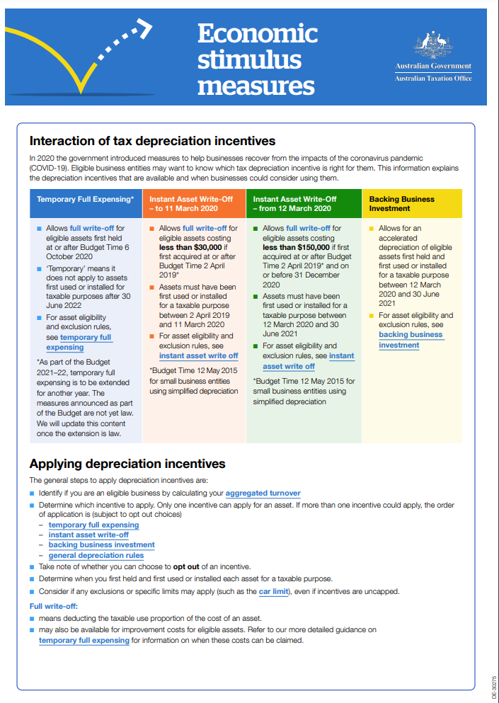

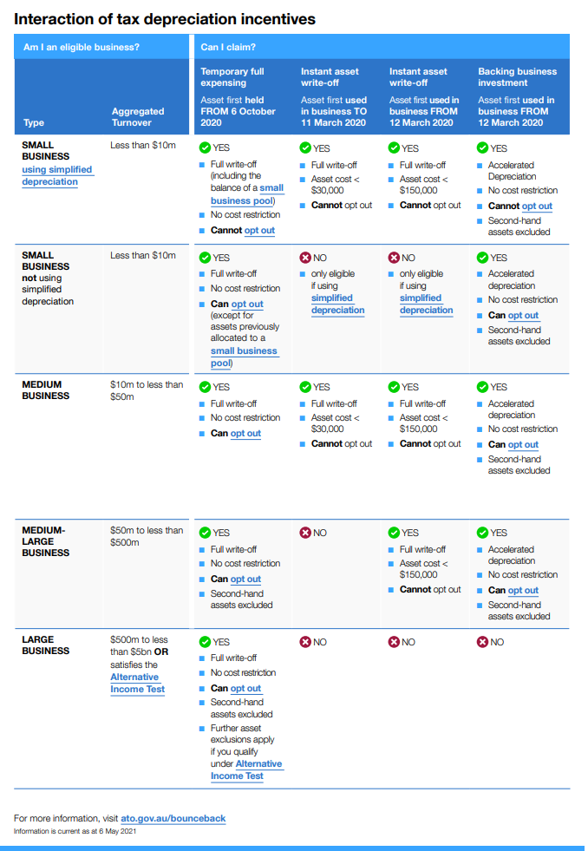

It was announced in the 2021-22 Federal Budget that the TFE measures will be extended to 30 June 2023.
There are exceptions, for example the amount above the motor vehicle depreciation limit.

